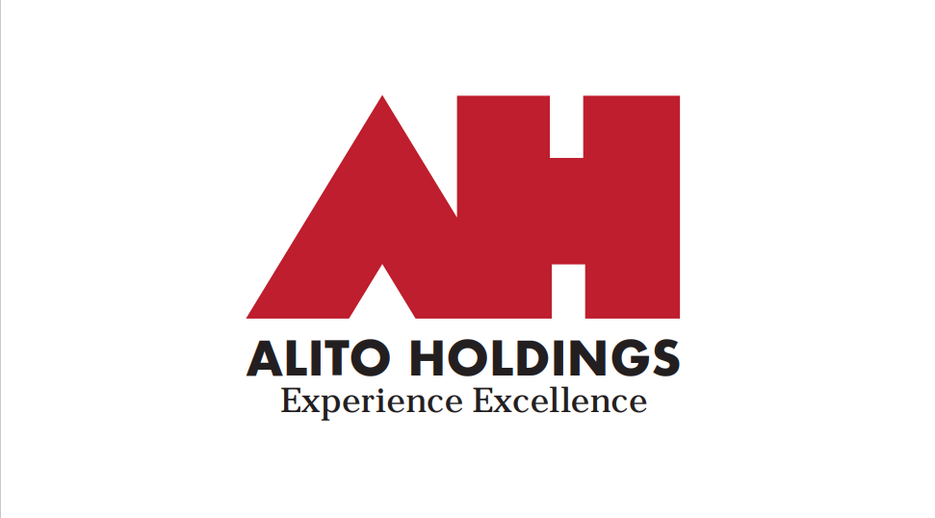

Dear Prospective Tenant,

Thank you for your interest in our rental apartments. We are committed to providing a safe, comfortable, and well-maintained living environment for our tenants. To help ensure that we find responsible and reliable tenants, we have established the following minimum qualification standards:

* Income: You must have a monthly income that is at least **3** times the monthly rent. You will need to provide proof of income (bank statements or pay stubs).
* Employment Verification: We will verify your employment status to ensure that you have a stable income source and are able to pay rent on time.
* Background Check: We will conduct a criminal background check to ensure that you do not have a criminal history.
* Credit Check: We will conduct a credit check to ensure that you have a history of paying bills on time and managing debt responsibly.

**Please note as the next step to the application process we require you to email your last two months' bank statements to alitorentals@gmail.com to verify your income. You will hear back from us within 24 - 48 hours after submitting this application AND your bank statements for income verification.**

Leases are signed electronically, and payments are made through bank auto draft with an account and routing number you provide. We require one month's rent at lease signing. Also a security deposit and last month's rent are due when you get the keys to your apartment. If you meet these minimum qualification standards and are interested in renting one of our apartments, please complete our rental application and provide any additional information that may be requested. Thank you for your interest, and we look forward to hearing from you.

Alito Holdings LLC

[www.alitoholdings.com](http://www.alitoholdings.com)

Email: alitorentals@gmail.com

24 South 8th Street Allentown PA